**KNN Assignment**

**What are the key hyperparameters in KNN?**

In K-Nearest Neighbors (KNN), the key hyperparameters include:

1. K (Number of Neighbors): This determines how many neighbors will be considered when making a prediction. A small K can be sensitive to noise, while a large K can smooth out the decision boundary too much.
2. Distance Metric: The method used to calculate the distance between data points. Common choices include Euclidean, Manhattan, and Minkowski distances. The choice of distance metric can significantly affect model performance.
3. Weighting Function: This determines how the influence of neighbors is calculated. Options typically include uniform weighting (all neighbors have equal weight) and distance weighting (closer neighbors have more influence).
4. Algorithm: The method used to compute the nearest neighbors. Options include brute force, kd-tree, or ball-tree. The choice can affect computational efficiency, especially with large datasets.
5. Leaf Size: Relevant when using tree-based algorithms, this parameter controls the size of the leaves in the tree structure, affecting the trade-off between search speed and memory usage.
6. p (Minkowski Parameter): When using the Minkowski distance, this parameter determines the norm (with p=1 for Manhattan distance and p=2 for Euclidean distance).
7. **What distance metrics can be used in KNN?**

In K-Nearest Neighbors (KNN), several distance metrics can be used to measure the similarity between data points. Here are some commonly used metrics:

1. Euclidean Distance: The most common metric, calculated as the straight-line distance between two points in Euclidean space. It's defined as:

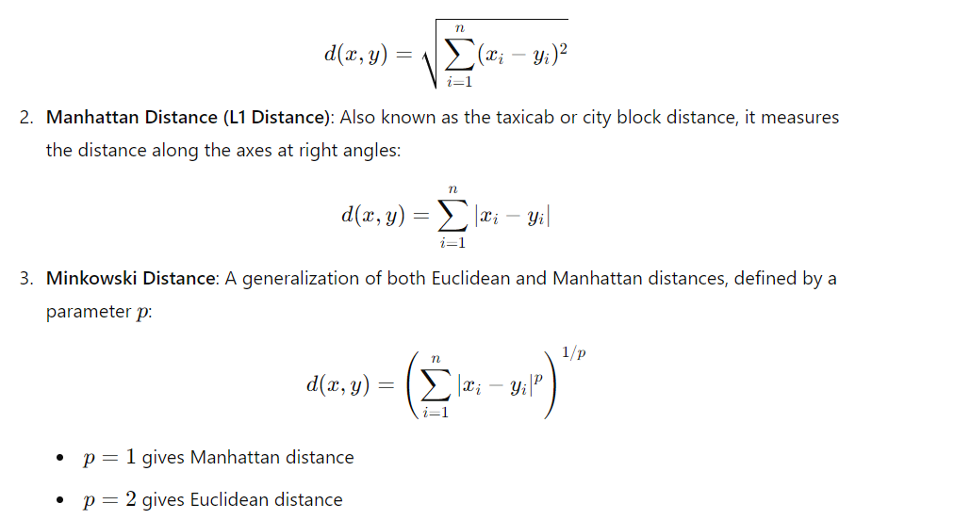

1. **Chebyshev Distance**: Measures the maximum distance along any coordinate dimension, defined as:

